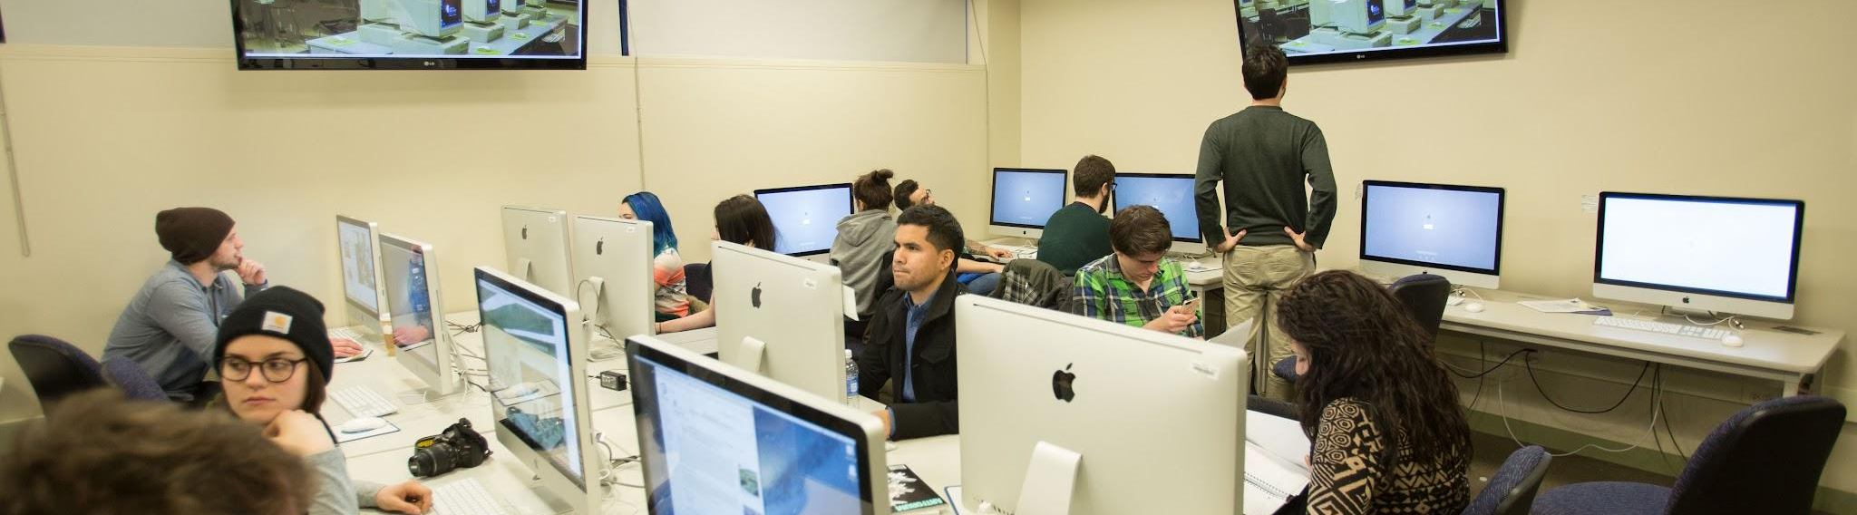
- Coming to Lab Part - we are primarily focusing on:
- Cloud Computing
- Amazon Web Services
- Microsoft Azure
- Google Cloud Platform

- Data Science
- Jupyter Labs

- To host Labs, we have two ways -
- Manual
- Automated

— Manual Way
- We manually create X number of users for the client (On Request)
- We need to make a note of:
- No. of Users
- List of Services
- Pricing
- No. of Days

Model Architecture: 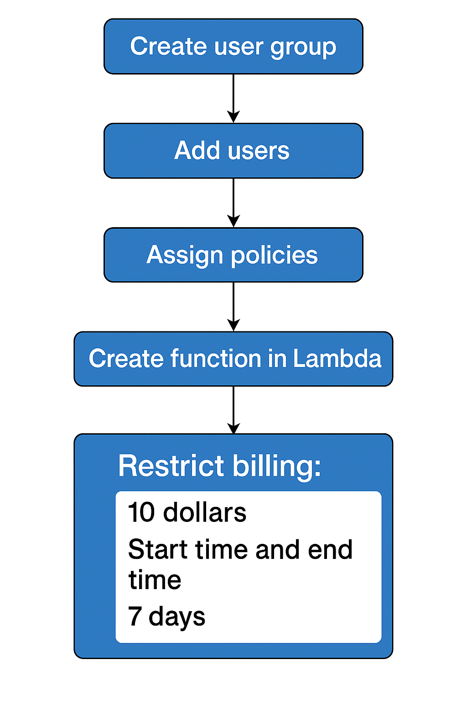
— Automated Way
- When a user requests X no. of accounts:
- Single Sign-On (which provides temporary credentials)
- List of Services
- Regions - we allow
- Billings Restricted
- Time slots (start time & end time)

